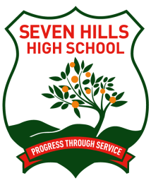 | Seven Hills High School  Year 10 Formal Policy
Implementation Date: February 2017 |  |  | Review Date: December 2020

For a student to attend the Year 10 Formal
- He/she must be enrolled at Seven Hills High School.
- All agreed financial commitments must have been met. These commitments include Stage 5 subject fees and any educational activities for which the requirement of payment has been accepted by the parent and /or the student.
N.B. All parents have the opportunity to pay the required monies through instalments. Some parents may be eligible to receive financial support for the payment of subject fees and other course requirements through limited student assistance funding.
- All school resources, such as library books, textbooks, sports uniforms, etc, loaned to a student are to have been returned or the school reimbursed for lost items.
- Students must have complied with the policies and procedures of Seven Hills High School relating to behaviour, uniform, attendance and learning.

Issuing of a Formal Denial Letter
A student who displays a pattern of non-compliance (including ‘N’ Award notifications) or whose behaviour warrants the issuing of a formal caution or suspension from school will have their right to attend the Year 10 Formal revoked. Both the student and their parents will be advised of this decision via a Formal Denial Letter.
For the student to have the right to attend the formal reinstated, they must ensure that their behaviour, attendance, uniform and learning are exemplary for the remainder of the school year.

Formal Denial Appeal Process
A student receiving a Formal Denial Letter will have the right to appeal the determination and present a case for attending the formal to a meeting of The Year 10 Formal Review Committee in Term 4. In addition to hearing a student’s case, the committee will review evidence such as attendance and behaviour data before making a determination.
Students will receive a letter to indicate the outcome of their appeal.

