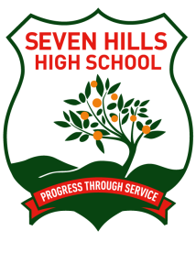
Seven Hills High School

Smoking Policy

Smoking is banned at Seven Hills High School. Students smoking on school grounds, or in school uniform on their way to or from school are in breach school’s Discipline Policy. Students in possession of cigarettes will be considered as smokers and will incur the same consequences as a smoker.

Stage 1 – (First notified occurrence)
Student to be referred to the Deputy Principal.
Student given a copy of School Smoking Policy and parent is notified. Student receives a lunchtime detention.

Stage 2 – (Second occurrence)
Student to be cautioned by Principal or delegate and letter sent to parent. Student to receive a Wednesday Morning Detention.

Stage 3 – (Third occurrence)
Student to be suspended. Counselling, parent interviews, new plan developed and contract not to smoke will be developed.

Stage 4 – (Fourth occurrence)
Student to be suspended (repeat Stage 3) and parent and student given final caution re smoking.

Stage 5 – (Fifth occurrence)
Students will enter into a long suspension.

The above stages form the School's Policy to notification by staff for repeated smoking offences over a period of approximately one year. If there is an extended period of time between offences then a particular step might be repeated.

