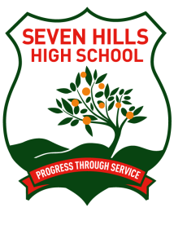 | Seven Hills High School  Reporting to Parents Policy
Implementation Date: February 2016 |  |  | Review Date: December 2017
Seven Hills High School will provide parents/carers, throughout the school year, with formal and informal opportunities to receive information about and discuss their child’s learning.
Parent/Teacher Evenings will be held in Terms 2 and 3. Parents are actively encouraged to discuss their child’s progress with their classroom teacher at mutually arranged times during any stage of the school year.
Seven Hills High School will provide parents/carers with a report on their child’s learning three times per year. The first report will be provided at the end of Term 1 each year and will grade their progress and attitude to learning. Half Yearly and Yearly Reports will also be provided at the end of Terms 2 and 4.
The Half Yearly and Yearly Reports for each student will:
- provide information on a student’s learning in each of the key learning areas (KLAs) or subjects;
- compare the student’s achievement in each KLA or subject against state wide syllabus standards using an A-E scale;
- provide information on how a child’s achievement compares with the child’s peer group at the school;
- include teacher comments for each KLA or subject which will identify areas of student strength and areas for further development;
- provide information about the student’s social development and commitment to learning;
- have information about the student’s attendance at school;
- have information about the student’s level of uniform compliance; and
- provide information about student achievement in relation to school programs that extend or are additional to syllabus requirements.
Seven Hills High School will disseminate to parents/carers the reports from national and state-wide testing programs and, as appropriate, will provide opportunity for discussion between teachers and parents/carers.

