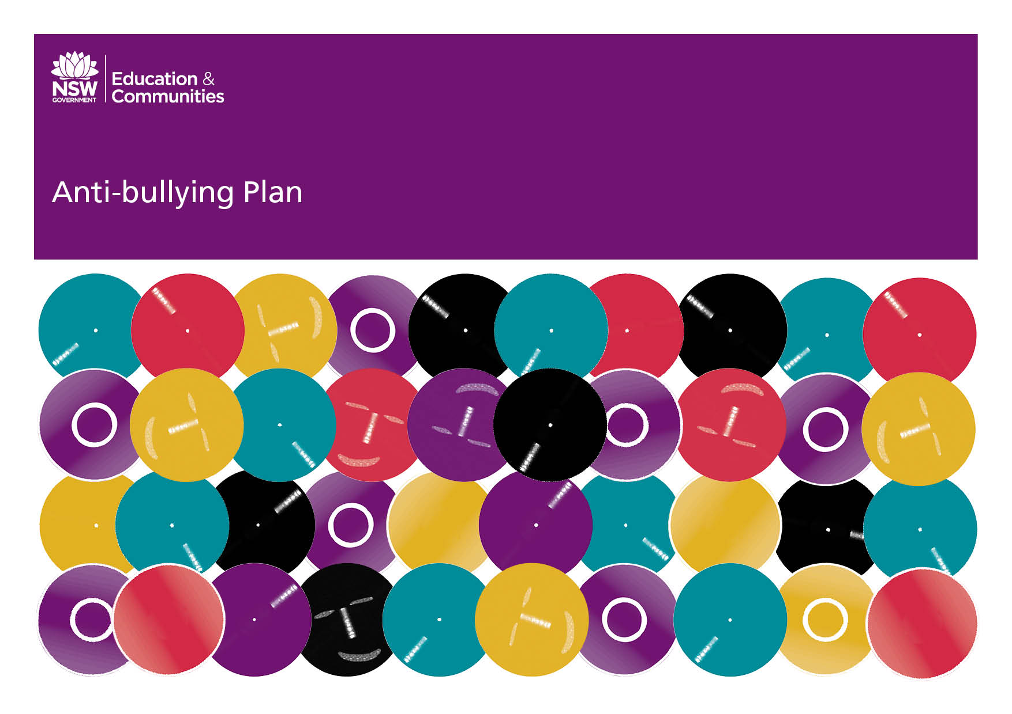
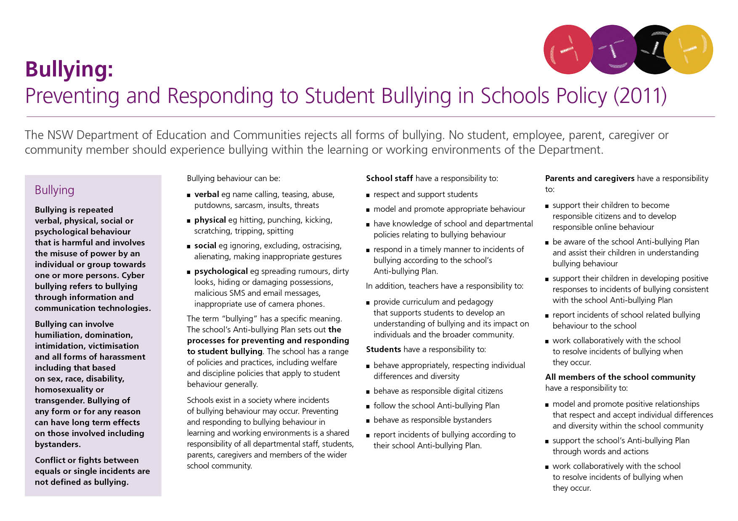
Our School Anti-Bullying Plan
Seven Hills High School

Our School Anti-Bullying Plan
This plan outlines the processes for preventing and responding to student bullying in our school and reflects the Bullying: Preventing and Responding to Student Bullying in Schools Policy of the New South Wales Department of Education and Communities.
In developing, implementing, monitoring and evaluating this plan, staff have been consulted through staff meetings and through representation in the Welfare Committee. Parents have consulted through the Parents and Citizens Association. Students have consulted through the Student Representative Council.
Statement of Purpose
Seven Hills High School will provide a positive culture where bullying, harassment and intimidation are not accepted and in doing so, all will have the right of respect from others, the right to learn or to teach and a right to feel safe and secure in their school environment. This is to be reinforced through the ROAD ethos which exists at the school.
Protection

A person is being bullied when one or more other people expose them regularly and over time to negative or harmful actions that cause distress, hurt and undue pressure. Bullying can involve all forms of harassment (including sex, race, disability, homosexuality or transgender), humiliation, domination and intimidation of others.

Cyber Bullying is bullying that is carried out through an internet service, such as email, chat room, discussion group or instant messaging. It can also include bullying through mobile phone technologies such as Snap chat and in-phone cameras. The school will actively intervene where this type of behaviour is evident and will involve outside agencies where necessary.
Bullies are people who deliberately set out to intimidate, exclude, threaten and/or hurt others repeatedly.
Bullying behaviour can be:
- verbal – e.g. name calling, teasing, abuse, putdowns, sarcasm, insults, threats.
- physical – e.g. hitting, punching, kicking, scratching, tripping, spitting.
- social – e.g. ignoring, excluding, ostracising, alienating, making inappropriate gestures.
- psychological – e.g. spreading rumours, dirty looks, hiding or damaging possessions, malicious SMS or email messages, inappropriate use of camera phones.
Bullying, in any form, is not tolerated at any level at Seven Hills High School.

Prevention
- School Newsletters and Information Evenings provide the community with information regarding Anti-Bullying and Complaints Handling Policies
- Community awareness and input relating to bullying, its characteristics and the school’s programs and responses via the Parents and Citizens Association.
- Student Representative Council to lead and model student anti-bullying behaviours.
- Professional development for all staff in general and Wellbeing staff in particular relating to bullying, harassment and proven counter measures at Staff Meetings. This will include annual and intermittent inservicing on Child Protection and Child Wellbeing issues.
- The school’s Positive Behaviour for Learning (ROAD) program to further support this professional development through its focus on respectful relationships and behaviour. This will include the communication to staff of observations made through the regular monitoring of bullying data made in Sentral (the school’s electronic reporting system).
- Transition Coordinator to liaise with primary schools to develop an understanding of the welfare needs of students entering high school.
- Student Wellbeing Team to develop, evaluate and refine strategies and processes to support students and parents as partners in the education of students in living skills.
This will be a particular focus for Special Education Unit students.
- The ARCO to provide counselling and advice for NESB students in line with DoE’s Complaints Handling Policy.
- Curriculum areas to include bullying issues (e.g. PDHPE, English topics etc)
- Peer Support program for Year 7 students led by Year 10 students that include anti-bullying sessions.
- The provision of student programs in all years that promote resilience, life and social skills, assertiveness, conflict resolution and problem solving.
Early Intervention
- Students and staff reporting incidents of bullying through the Student Year Adviser, Head Teacher Wellbeing, the Deputy Principals and Principal.
- Parents and caregivers are encouraged to contact the school and notify the Student Year Advisor, Head Teacher Wellbeing, the Deputy Principals and Principal if they become aware of bullying problems.
- A record of interview with community members is maintained and disseminated to HT Wellbeing and Deputy Principals for determination of method of response.
- Staff and students identify incidents of bullying through the school referral system. These referrals are disseminated to HT Wellbeing and Deputy Principals for determination of method of response.
- Targeted programs aimed at developing confidence in students to manage aggression from others, to control their own emotions and to develop resilience and self-esteem.
- Welfare systems provide a means for all teachers to communicate issues with a view to planning and implementing effective responses.

Response
- A record of interview with community members is maintained and disseminated to HT Wellbeing and Deputy Principals for determination of method of response. The school will investigate and respond to the incident within 2 working days.
- Staff and students identify incidents of bullying through the school referral system. These referrals are disseminated to HT Wellbeing and Deputy Principals for determination of method of response. The school will investigate and respond to the incident within 2 working days.
- The Principal, Deputy Principal, HT Wellbeing and School Counsellor will consult, as appropriate, as to the method of intervention to be employed
- Students identified as bullies will be informed of allegations and have an opportunity to respond to those allegations.
- Bullies, victims and witnesses will be offered counselling and support.
- Restorative Justice Model of counselling will be employed whenever appropriate.
- Where appropriate, mediation for victims and bullies will occur under the guidance of Wellbeing personnel.
- To assist in the resolution of bullying issues appropriate parties will be engaged as required.
- If student bullying persists, consequences will be implemented consistent with the School’s Discipline Policy.
Post Incident
Strategies employed will be individually based and may include…
- Counselling from appropriate staff members or outside agencies for all parties.
- Implementing the shared method of concern.
- Mediation with appropriate members of the welfare team.
- Explicit teaching of strategies to encourage self-esteem and resilience.
- Withdrawal of privileges.
- Exclusion from class or playground if appropriate.
- Suspension.
- Reinforcement of positive social behaviours through mentoring
- Monitoring of the effectiveness of post-violation programs through student monitoring cards, the computerised welfare monitoring system and student conferencing.
- The school will provide parents and caregivers with follow up information, within the bounds of privacy legislation, about the management of bullying incidents that have been reported to the school. This may occur through phone interviews, personal interviews with the Principal, Deputy Principal, Head Teacher Wellbeing or School Counsellor.
- The school reports all incidents involving assaults, threats, intimidation or harassment to the Safety and Security Directorate and the police in accordance with the DoE the Incident Reporting Procedures.
- The Principal, Deputy Principals or Head Teacher Wellbeing will use the mandatory Reporters Guidelines to determine the need for the support of the Child Wellbeing Unit or Community Services.
- The Complaints Handling Policy (available on the school website) is one avenue by which parents, community members and students complaints of bullying can be addressed.
- The effectiveness of the Anti-bullying Plan will be monitored through the school’s welfare database system by the Wellbeing Team.
Evaluation
- This policy will be reviewed with input from the whole staff and representatives from the student, parent and community as part of the school’s review cycle.
- The success of the Anti-bullying Plan will be communicated to the Parents and Citizens Association annually.
- The Anti-bullying plan will be reviewed in collaboration with the Parents and Citizens Association in February of each year.
Additional Information
The Police Youth Liaison Officer (YLO) for Seven Hills High School is Const. Amanda Jones (Riverstone LAC)
Kids Helpline 1800 55 1800
Quakers Hill Youth Support Services 9837 0106
Headspace 9675 2602
Principal’s comment
This plan is designed to ensure that positive social behaviours are promoted throughout the school and to ensure that all reported incidents are effective managed, in accordance with DoE guidelines.
This plan was developed by
Greg Johnstone Principal
Matthew Maclaren Head Teacher Wellbeing
School contact information
Seven Hills High School
Johnson Ave Seven Hills 2154
Ph: 9624 3329
Fax: 9838 8553
Email: sevenhills-h.school@det.nsw.edu.au
Web: http://www.sevenhills-h.schools.nsw.edu.au/

