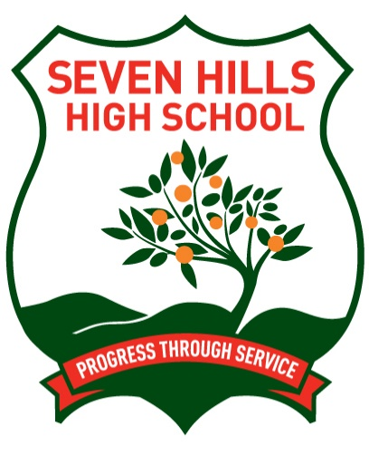

Seven Hills High School

Year 10

**Assessment Schedule**

2023

**Year 10**

**Term 1**

|  |  |
| --- | --- |
| Week | Task |
| **1**  **23 Jan – 27 Jan** |  |
| **2**  **30 Jan – 3 Feb** |  |
| **3**  **6 Feb – 10 Feb** |  |
| **4**  **13 Feb – 17 Feb** |  |
| **5**  **20 Feb – 24 Feb** | * Life Skills Science – Take Home Task Due |
| **6**  **27 Feb – 3 Mar** | **School Swimming Carnival**   * Mathematics – In Class Test * Life Skills HSIE – Research Task |
| **7**  **6 Mar – 10 Mar** | * Life Skills Mathematics – Take Home Task Due * History – Take home task due |
| **8**  **13 Mar – 17 Mar** | * Life Skills Mathematics – Take Home Task Due * PASS – Take Home Task Due * Commerce – Research Task Due |
| **9**  **20 Mar – 24 Mar** | * English – In Class Task * Science – Take Home Task SRP Due * Visual Arts – Portfolio/BOW Due * Digital Media – Portfolio/BOW Due * Music – Take home task due |
| **10**  **27 Mar – 31 Marc** | * Food Technology – Research and Practical Task Due * PDHPE – Take Home Task Due |
| **11**  **3 Apr – 7 Apr** |  |

**Year 10**

**Term 2**

|  |  |
| --- | --- |
| Week | Task |
| **1**  **24 Apr – 28 Apr** | **School Athletics Carnival** |
| **2**  **1 May – 5 May** |  |
| **3**  **8 May – 12 May** | * Food Technology – Practical Test |
| **4**  **15 May – 19 May** | * Semester 1 Examinations - English, Mathematics, History, Science (includes Life Skills courses for subjects stated) |
| **5**  **22 May – 26 May** | * Semester 1 Examinations - Digital Media, Music, Commerce and Visual Arts (includes Life Skills courses for subjects stated) * PDHPE – In Class Practical Test * PASS – Practical Skills Test |
| **6**  **29 May – 2 Jun** |  |
| **7**  **5 Jun – 9 Jun** |  |
| **8**  **12 Jun – 16 Jun** |  |
| **9**  **19 Jun – 23 Jun** |  |
| **10**  **26 Jun – 30 Jun** |  |

**Year 10**

**Term 3**

|  |  |
| --- | --- |
| Week | Task |
| **1**  **17 Jul – 21 Jul** |  |
| **2**  **24 Jul – 28 Jul** |  |
| **3**  **31 Jul – 4 Aug** |  |
| **4**  **7 Aug – 11 Aug** |  |
| **5**  **14 Aug – 18 Aug** | * Science – Take Home Research Task Due |
| **6**  **21 Aug – 25 Aug** | * Geography – Take Home Task Due * Life Skills Mathematics – In Class Test * Mathematics – Take Home Task Due |
| **7**  **28 Aug – 1 Sep** | * Life Skills HSIE – Take home task due * PASS – Take Home Task Due |
| **8**  **4 Sep – 8 Sep** | * Life Skills English – In Class Task * Visual Arts – Body of Work Due * Digital Media – Body of Work Due * English – Take Home Task Due |
| **9**  **11 Sep – 15 Sep** | * Life Skills Science – Take home task due * PDHPE – Practical Skills Test * Music – Performance * Commerce – Research Task Due * Food Technology – Research and Practical Task Due |
| **10**  **18 Sep – 22 Sep** |  |

**Year 10**

**Term 4**

|  |  |
| --- | --- |
| Week | Task |
| **1**  **9 Oct – 13 Oct** |  |
| **2**  **16 Oct – 20 Oct** | * Semester 2 Elective Examinations - Digital Media, Music, Commerce and Visual Arts (includes Life Skills courses for subjects stated) |
| **3**  **23 Oct – 27 Oct** | * Semester 2 Examinations - English, Mathematics, Geography, Science, PDHPE (includes Life Skills courses for subjects stated) * Food Technology – Practical test |
| **4**  **30 Oct – 3 Nov** | * PASS – Practical Skills Test |
| **5**  **6 Nov – 10 Nov** |  |
| **6**  **13 Nov – 17 Nov** |  |
| **7**  **20 Nov – 25 Nov** |  |
| **8**  **28 Nov – 1 Dec** |  |
| **9**  **4 Nov – 8 Dec** |  |
| **10**  **11 Dec – 15 Dec** |  |
| **11**  **18 Dec – 22 Dec** |  |